VIETNAM GENERAL CONFEDERATION OF LABOUR

**TON DUC THANG UNIVERSITY**

**FACULTY OF INFORMATION TECHNOLOGY**



**NGUYEN DINH VIET HOANG - 522H0120**

**FINAL REPORT**

**INTRODUCTION TO COMPUTER VISION**

**HO CHI MINH CITY, YEAR 2024**

VIETNAM GENERAL CONFEDERATION OF LABOUR

**TON DUC THANG UNIVERSITY**

**FACULTY OF INFORMATION TECHNOLOGY**



**NGUYEN DINH VIET HOANG - 522H0120**

**FINAL REPORT**

**INTRODUCTION TO COMPUTER VISION**

Advised by

**PhD. PHAM VAN HUY**

**HO CHI MINH CITY, YEAR 2024**

**ACKNOWLEDGEMENT**

We sincerely thank PhD. Pham Van Huy for teaching us the Introduction to Computer Vision course with great enthusiasm. We want to express our deep appreciation for the dedication and professional knowledge that you shared with us. Through your classes, we gained a better understanding of the fundamental aspects of the Introduction to Computer Vision, thanks to your detailed explanations and practical applications. You helped us grasp the knowledge and apply it effectively. Finally, we extend our heartfelt gratitude to PhD. Pham Van Huy for your commitment and invaluable support throughout our learning journey in this course. The skills and knowledge we acquired will continue to impact our future development. We sincerely thank you and wish your health, success, and happiness.

*Ho Chi Minh City, December 21, 2024*

*Author:*

*Nguyen Dinh Viet Hoang*

**DECLARATION OF AUTHORSHIP**

We hereby declare that this thesis was carried out by ourselves under the guidance and supervision of PhD. Pham Van Huy; and that the work and the results contained in it are original and have not been submitted anywhere for any previous purposes. The data and figures presented in this thesis are for analysis, comments, and evaluations from various resources by our own work and have been duly acknowledged in the reference part.

In addition, other comments, reviews and data used by other authors, and organizations have been acknowledged, and explicitly cited.

We will take full responsibility for any fraud detected in my thesis. Ton Duc Thang University is unrelated to any copyright infringement caused on my work (if any).

*Ho Chi Minh City, December 21, 2024*

*Author:*

*Nguyen Dinh Viet Hoang*

**ABSTRACT**

Convolutional Neural Networks (CNNs) have revolutionized the field of computer vision and inspired subsequent advancements in deep learning architectures, such as AlexNet, Vision Transformer (ViT), R-CNN, Autoencoder, and Generative Adversarial Networks (GANs). This document provides an overview of CNNs, their key milestones, and applications, discussing their role in feature extraction, image processing, and pattern recognition. The transition from CNN-based methods to Transformer-based architectures like ViT underscores the evolution of computer vision techniques. Moreover, modern innovations such as R-CNN and its derivatives (Fast R-CNN, Faster R-CNN, Mask R-CNN), Autoencoders, and GANs demonstrate their adaptability to diverse tasks, including object detection, segmentation, data compression, and synthetic data generation. These advancements highlight the interplay between foundational techniques and state-of-the-art methodologies, bridging the gap between traditional computer vision and contemporary artificial intelligence solutions.

**TABLE OF CONTENTS**

LIST OF FIGURES xi

CHAPTER 1. INTRODUCTION TO CNN 1

1.1. The Context of CNN Formation 1

1.2. Other Key Milestones 1

1.3. Advantages and Disadvantages of CNN 1

1.4. Applications of CNN in Modern Life 2

1.5. Key Improvements in CNN 2

1.6. Basic layers of CNN 3

1.6.1. Convolutional Layer 4

1.6.2. ReLU Layer 4

1.6.3. Pooling Layer 4

1.6.4. Fully Connected Layer 4

1.6.5. Activation function 5

1.7. Structure of CNN 5

1.8. Guidelines for Selecting Parameters for CNN 6

1.9. Convolution in RGB Images 7

CHAPTER 2. INTRODUCTION TO ALEXNET 8

2.1. Introduction 8

2.2. Architecture 9

2.3. Why use ReLU? 10

2.4. Drawbacks of ReLU 11

2.5. Activation Functions: Sigmoid, Tanh, and ReLU 11

2.6. Local Response Normalization 12

2.7. Comparison of AlexNet with the older and newer models 12

CHAPTER 3. INTRODUCTION TO VIT 13

3.1. What is Vision Transformer? 13

3.2. History of Transformer 14

3.3. Architecture of ViT 15

3.3.1. Dividing Images into Patches 15

3.3.2. Creating Embeddings for Patches 16

3.3.3. Transformer Encoder 16

3.3.4. Classification Head 16

3.4. How Vision Transformers Work 17

3.4.1. Multi-Head Self-Attention (MHSA) 18

3.4.2. Multi-Head Attention 18

3.4.3. Positional Encoding 18

3.5. Differences Between CNNs and Vision Transformers (ViT) 19

3.5.1. Architecture and Working Principles 19

3.5.2. Performance and Efficiency 19

3.5.3. Strengths 20

3.5.4. Weaknesses 20

3.5.5. Applications 21

3.6. Advantages of Vision Transformers 21

3.6.1. Superior Performance on Large Datasets 21

3.6.2. Strong Generalization Capabilities 21

3.6.3. Powerful Attention Mechanism 22

3.7. Limitations of Vision Transformers 22

3.7.1. Requires Large Datasets 22

3.7.2. Computational Complexity 22

3.7.3. Inefficient for Local Information 22

3.8. Applications of Vision Transformers 22

3.8.1. Healthcare 22

3.8.2. Retail and E-commerce 22

3.8.3. Security and Surveillance 23

CHAPTER 4. INTRODUCTION TO R-CNN AND ITS VERSIONS 24

4.1. The introduction to R-CNN 24

4.1.1. Basic concepts 24

4.1.2. The architecture will be divided into 3 steps 24

4.1.3. Advantages 25

4.1.4. Disadvantages 25

4.1.5. Improved versions 25

4.2. The introduction to Fast R-CNN 26

4.2.1. Description 26

4.2.2. Advantages 26

4.2.3. Disadvantages: 26

4.3. The introduction to Faster R-CNN 28

4.3.1. Key Components of Faster R-CNN 29

4.3.2. Architecture Workflow 30

4.3.3. Advantages of Faster R-CNN 31

4.3.4. Limitations 31

4.3.5. Applications 31

4.3.6. Advances and Variants 32

4.3.7. Modern Improvements 32

4.3.8. Comparison with Other Object Detectors 32

4.4. The introduction to Mask R-CNN 33

4.4.1. What is Mask R-CNN? 33

4.4.2. Architecture of Mask R-CNN 34

4.4.3. Key Improvements 35

4.4.4. Advantages of Mask R-CNN 35

4.4.5. Applications 35

4.4.6. Datasets and Evaluation 35

4.4.7. Limitations 36

CHAPTER 5. INTRODUCTION TO AUTOENCODER 37

5.1. Overview of Autoencoder 37

5.2. Autoencoder Architecture 37

5.3. Loss Function 38

5.4. Types of Autoencoders 39

5.5. Applications of Autoencoder 40

5.6. Advantages and Limitations of Autoencoder 40

CHAPTER 6. INTRODUCTION TO GAN 41

6.1. Overview of GAN 41

6.2. Basic Structure of GAN 41

6.3. Working Principle of GAN 42

6.4. Training Procedure 43

6.5. Common Challenges in GAN 43

6.6. Variants of GAN 43

6.7. Applications of GAN 44

REFERENCES 45

# LIST OF FIGURES

Figure 1.6: Basic layers of CNN 3

Figure 1.7: Structure of CNN 5

Figure 1.8: Guidelines for Selecting Parameters for CNN 6

Figure 1.9: Convolution in RGB Images 7

Figure 2.2: Architecture of AlexNet 9

Figure 2.4: The drawbacks of ReLU 11

Figure 2.5: Activation Functions 12

Figure 2.6: Local Response Normalization (LRN) 12

Figure 3.1: An example of using ViT 14

Figure 3.2: History of Transformer 15

Figure 3.3: Architecture of ViT 17

Figure 3.5.1: Compare CNNs and ViT about Architecture and Working Principles 19

Figure 3.5.2: Compare CNNs and ViT about Performance and Efficiency 20

Figure 3.5.3: Compare CNNs and ViT about Strengths 20

Figure 3.5.4: Compare CNNs and ViT about Weaknesses 21

Figure 3.5.5: Compare CNNs and ViT about Applications 21

Figure 4.1: Basic concepts of R-CNN 24

Figure 4.2.a: Architecture of Fast R-CNN 27

Figure 4.2.b: Compare the runtime between models 28

Figure 4.3: Architecture of Faster R-CNN 29

Figure 4.4: Architecture of Mask R-CNN 33

Figure 5.2: Architecture of AutoEncoder 37

Figure 6.2: Architecture of GAN 42

# CHAPTER 1. INTRODUCTION TO CNN

1.1. The Context of CNN Formation

Before LeNet-5:

+ The idea of multilayer neural networks emerged in the 1980s, but training deep models faced challenges due to computational limitations and the vanishing gradient problem.

+ The development of the Backpropagation algorithm in the late 1980s and 1990s, along with advances in computational power, laid the groundwork for CNN.

LeNet-5 (1998):

+ Developed by Yann LeCun for handwritten character classification (e.g., postal code recognition on checks).

+ The model opened the first success in the field of computer vision and paved the way for later CNN models up to the present time.

1.2. Other Key Milestones

2006: Geoffrey Hinton introduced Deep Belief Networks (DBN), reviving interest in deep learning networks.

2009: The ImageNet dataset was released, providing a large collection of labeled images that accelerated the development of deep learning models.

2012: AlexNet won the ImageNet competition, reducing error rates by 10% compared to the best previous methods, confirming the power of CNN.

2014: The introduction of VGGNet and GoogleNet improved the depth and efficiency of CNN.

2015: ResNet (Residual Networks), introduced by Microsoft, enabled the training of extremely deep networks (hundreds of layers) without vanishing gradients.

1.3. Advantages and Disadvantages of CNN

+ Advantages:

* CNNs automatically find the most relevant features from data without manual intervention.
* Thanks to parameter sharing and local processing via convolution, CNN models are computationally more efficient than other models such as FNN or MLP.
* Can be applied to many types of data such as images, audio, video, and even text.

+ Disadvantages:

* CNN requires large datasets to perform well.
* Training a deep CNN often requires significant computational resources.
* It is challenging to understand the logic behind CNN decisions.

1.4. Applications of CNN in Modern Life

+ Computer Vision:

* Face Recognition.
* Object Detection.
* Image Classification.

+ Commercial Applications:

* Filtering inappropriate content on social media.
* Product recommendations on e-commerce platforms.

+ Automation and Self-driving cars:

* Lane detection and traffic sign recognition.
* Predicting the motion of objects on the road.

+ Healthcare:

* Medical imaging diagnosis, such as X-rays, MRIs, or CT scans.
* Tumor segmentation in medical images.

+ Natural Language Processing (NLP):

* Modeling text sequences with CNN for tasks like text classification and spam detection.

1.5. Key Improvements in CNN

+ Dropout (2012): Introduced in AlexNet to reduce overfitting.

+ Batch Normalization (2015): Helps speed up training and improve model performance.

+ Residual Connections (ResNet, 2015): Address the vanishing gradient problem in deep networks.

+ Attention Mechanism (2017): Enhances CNN’s focus on important regions in an image.

1.6. Basic layers of CNN

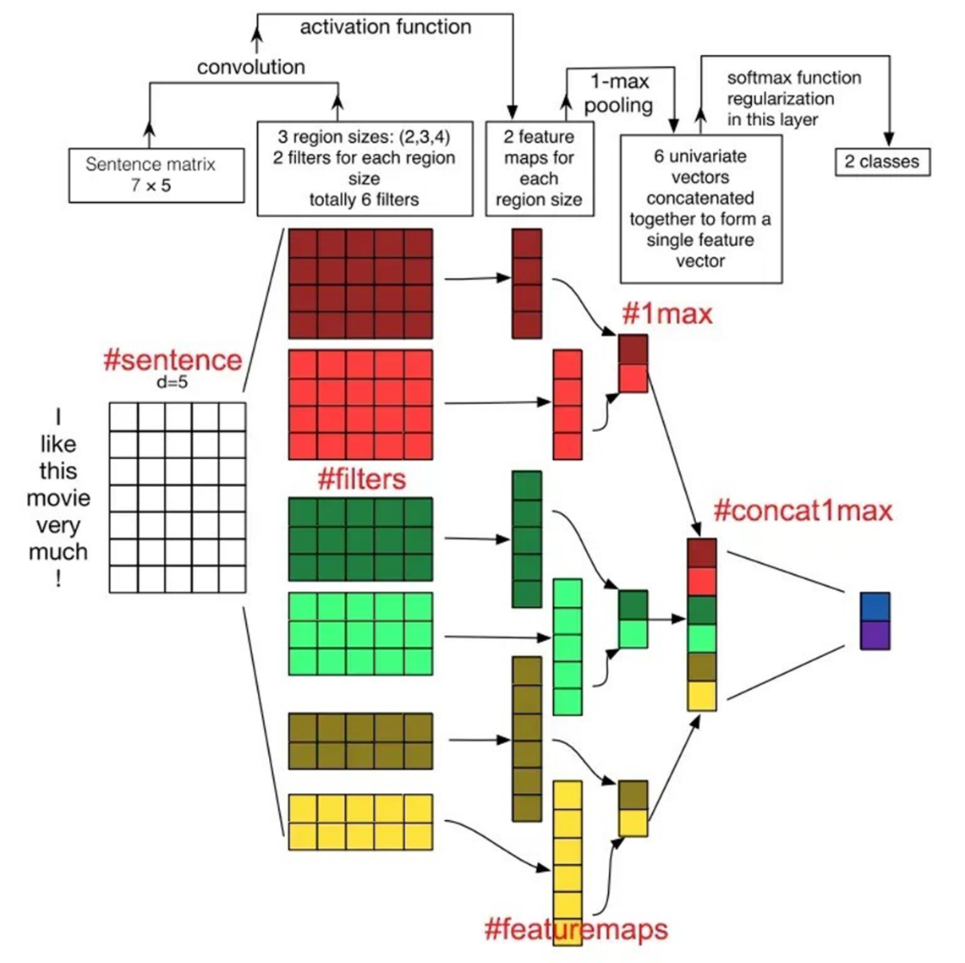

Figure 1.6: Basic layers of CNN

### *1.6.1. Convolutional Layer*

This is the core layer of CNN, responsible for performing all computations. Stride, padding, filter maps, and feature maps are the most important elements of the convolutional layer.

* + The mechanism of CNN involves creating filters that are applied to specific regions of an image. These **Filter maps** are 3-dimensional matrices containing parameters represented by numerical values.
  + **Stride**: The movement of the filter map in pixels, from left to right, based on a defined value.
  + **Padding**: Zero values added to the input layer to maintain the spatial dimensions of the output.
  + **Feature Map**: After each sweep, a computational process is executed. The feature map represents the result of the filter map sweeping over the input.

### *1.6.2. ReLU Layer*

Also known as an activation function, this is a function activated within neural networks. It simulates the rate at which neurons transmit impulses through axons. Common activation functions include ReLU, Tanh, Sigmoid, Maxout, and Leaky ReLU. The ReLU layer is widely used in neural network training due to its advanced benefits.

### *1.6.3. Pooling Layer*

When the input data size is too large, pooling layers are placed between convolutional layers to reduce the number of parameters. Pooling layers are commonly divided into two types: max pooling and average pooling.

### *1.6.4. Fully Connected Layer*

After the convolutional and pooling layers process the input image, the fully connected layer outputs the result. When the model extracts information from the image, this layer ensures connections to produce more outputs. This is when developers utilize the fully connected layer. Moreover, if the fully connected layer contains image data, it organizes them into unsegmented quality groups.

### *1.6.5. Activation function*

+ Usually using Sigmoid or Tanh.

+ The output of the last fully connected layer goes through the softmax function.

1.7. Structure of CNN

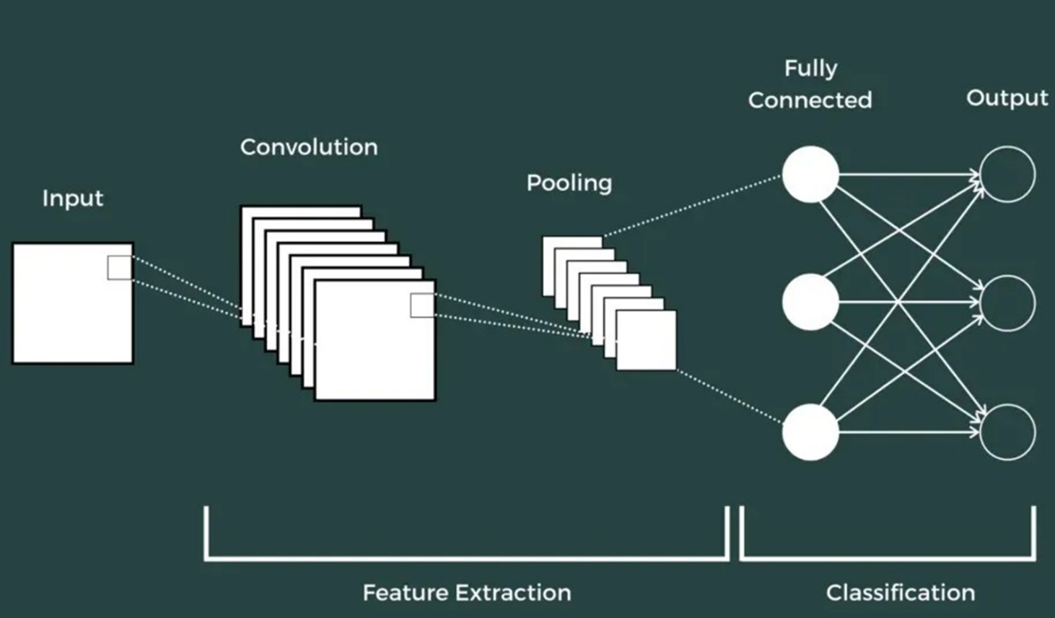

Figure 1.7: Structure of CNN

+ The basic structure of CNN consists of three main components:

* Local Receptive Field: The role of the local receptive field is to segment and filter data as well as image information, selecting the regions of the image with the highest value for use.
* Shared Weights and Bias: In CNNs, this component helps minimize the number of parameters significantly. Each convolution contains multiple feature maps, and each feature map has the ability to detect certain features in the image.
* Pooling Layer: The pooling layer is the final layer, responsible for simplifying the output information. After completing computations and sweeping through the layers, the pooling layer is created to eliminate unnecessary information and optimize the output. This ensures users receive results that meet their requirements and expectations.

1.8. Guidelines for Selecting Parameters for CNN

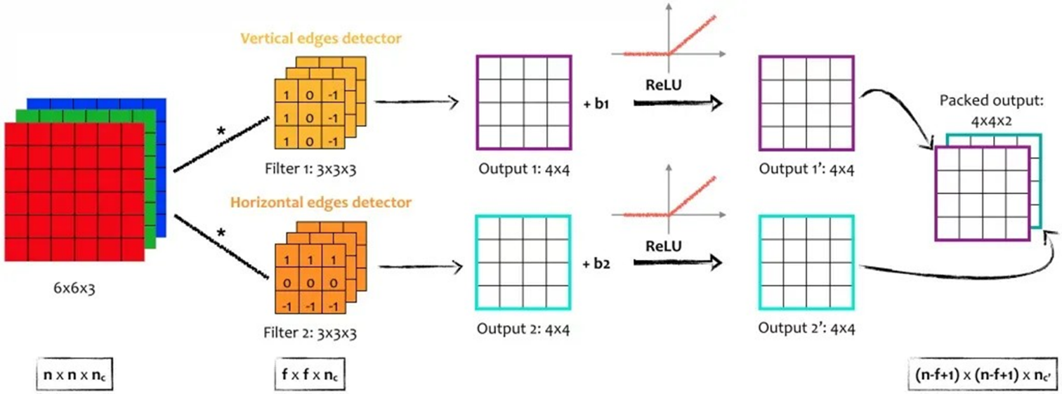

Figure 1.8: Guidelines for Selecting Parameters for CNN

+ To choose the most suitable parameters for CNN, consider the following key factors:

* Convolutional Layer:
  + The more convolutional layers you include, the better and more advanced your model will perform.
  + Using a larger number of layers can significantly reduce the effects of overfitting.
  + In most cases, having about 3 to 5 layers will yield satisfactory results.
* Filter Size:
  + Common filter sizes are 3×3 or 5×5.
* Pooling Size:
  + For standard images, it is recommended to use a pooling size of 2×2.
  + For larger input images, consider using a pooling size of 4×4.
* Train Test:
  + The more train-test iterations you perform, the higher the chances of obtaining optimal parameters, making your model "smarter" and more efficient.

1.9. Convolution in RGB Images

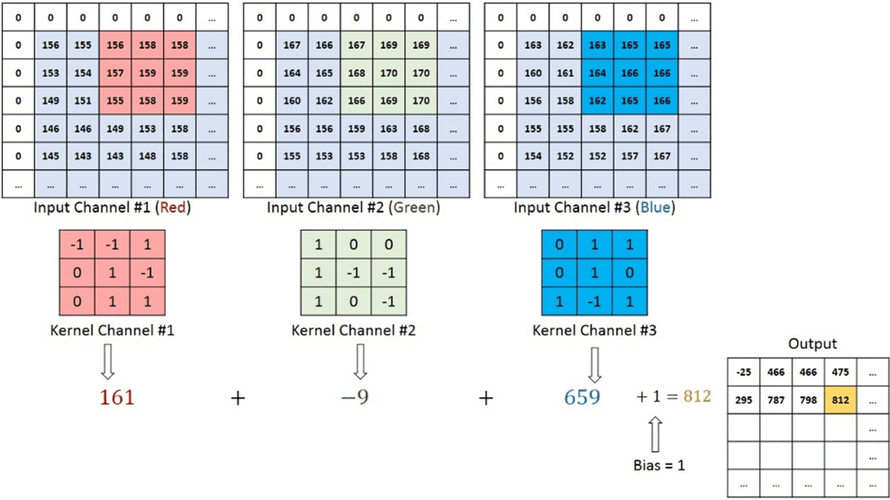

Figure 1.9: Convolution in RGB Images

+ On a convolutional layer, multiple kernels can be applied, with each kernel having its own unique weights and biases.

+ Purpose: This allows the network to extract various features from the input.

+ The output of a convolutional layer is then passed through one of two common activation functions:

* Sigmoid: A nonlinear activation function that maps values between 0 and 1.
* Tanh: Another nonlinear activation function that maps values between -1 and 1.

# CHAPTER 2. INTRODUCTION TO ALEXNET

2.1. Introduction

+ Introduced by Alex Krizhevsky, Ilya Sutskever, and Geoffrey Hinton in the ImageNet Large Scale Visual Recognition Challenge (ILSVRC) 2012.

+ Marked the prominence of Deep Learning in the field of computer vision.

+ In 2009, the ImageNet dataset, containing 1 million images evenly distributed across 1,000 classes, was introduced.

+ Traditional methods like SVM and Random Forests were unable to fully exploit the information from the ImageNet dataset.

2.2. Architecture

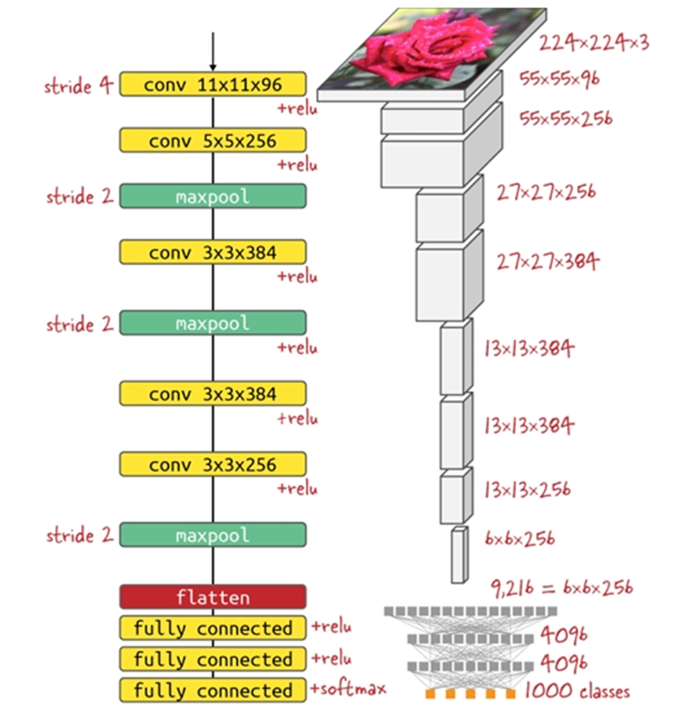

Figure 2.2: Architecture of AlexNet

+ Convolution Layers: 5 convolutional layers.

+ Pooling Layers: 3 pooling layers.

+ Fully Connected Layers: 3 fully connected layers.

+ Activation Function:

* ReLU is applied to the output of the Convolutional Layers and the first two Fully Connected layers.
* The logits after FC3 are passed through the softmax function.

+ Applied Dropout to reduce overfitting.

+ Used two parallel networks to process data (to leverage the limited GPU capacity at the time).

+ Leveraged GPU for training to improve efficiency.

+ Employed data augmentation techniques like flipping and rotation.

+ Integrated normalization after each convolutional layer (Local Response Normalization - LRN).

2.3. Why use ReLU?

+ ReLU is simple, increasing computational speed.

+ Reduces model complexity.

+ Avoids the gradient vanishing problem.

2.4. Drawbacks of ReLU

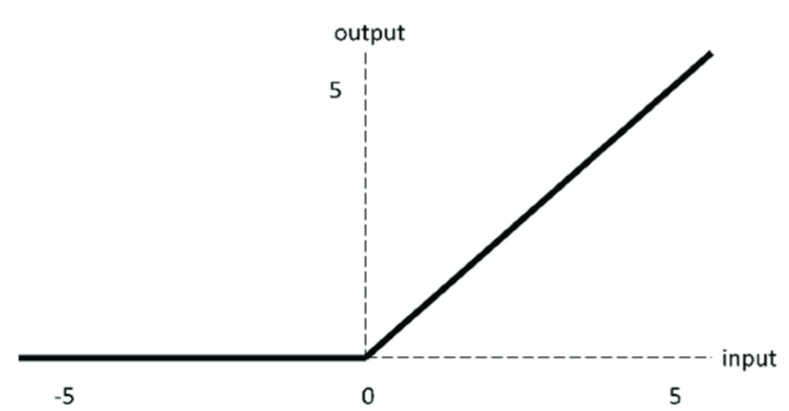

Figure 2.4: The drawbacks of ReLU

+ Values greater than 0 remain unchanged.

+ Values less than or equal to 0 are set to 0. => This can lead to gradient exploding or loss of information during learning.

2.5. Activation Functions: Sigmoid, Tanh, and ReLU

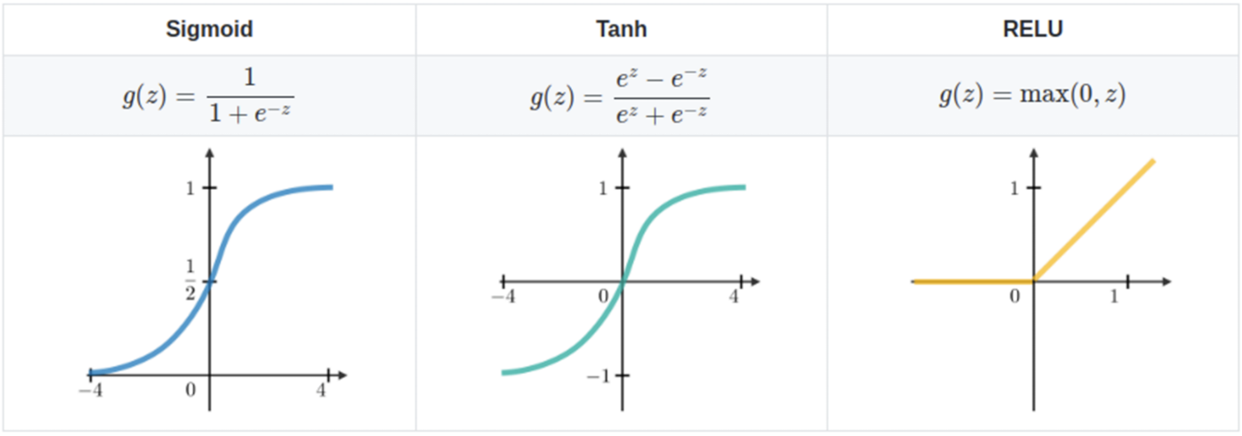

Figure 2.5: Activation Functions

2.6. Local Response Normalization

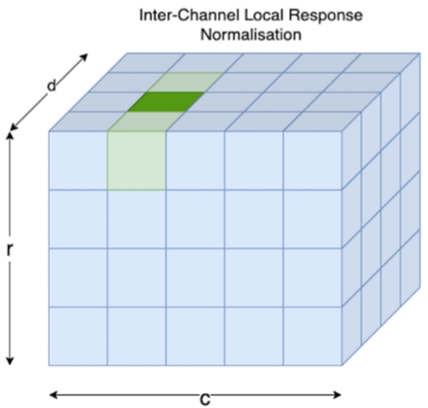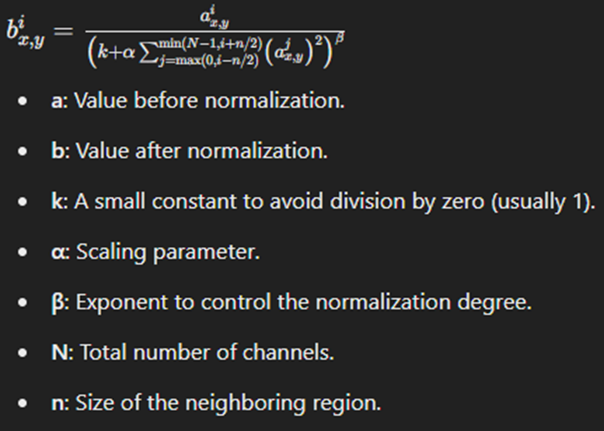

Figure 2.6: Local Response Normalization (LRN)

2.7. Comparison of AlexNet with the older and newer models

+ Compared to earlier models:

* Enabled the use of GPUs for training.
* Achieved a significantly lower error rate compared to prior models.
* Served as a foundational architecture for subsequent models like ResNet and GoogleNet.

+ Compared to newer models:

* Requires more training time due to the large model size (60 million parameters).
* Its large size makes it unsuitable for devices with limited hardware capabilities.
* Features a relatively simple architecture compared to newer models.

# CHAPTER 3. INTRODUCTION TO VIT

3.1. What is Vision Transformer?

While Transformer models have become the standard for Natural Language Processing (NLP) tasks, their applications in Computer Vision are still relatively few. In Computer Vision, the Attention mechanism is often used either in combination with Convolutional Neural Networks (CNNs) or to replace certain aspects of CNNs.

However, this dependence on CNNs is not mandatory. A pure Transformer model applied directly to sequences of image patches (rectangular segments containing closely located pixels large enough to describe objects in the image) can perform exceptionally well in image classification tasks.

Vision Transformers (ViT) is an advanced deep learning architecture designed for Computer Vision tasks. ViT utilizes the Transformer mechanism, which is highly popular in NLP, to completely replace convolutional layers (CNNs). The core idea of ViT is to divide images into patches (small sections) and process them as tokens, similar to NLP tasks.

ViT was introduced by Google Research in the renowned paper *"An Image is Worth 16x16 Words: Transformers for Image Recognition at Scale"* (2020). ViT achieved high accuracy on datasets like ImageNet and outperformed traditional CNN models like ResNet when trained on large-scale datasets.

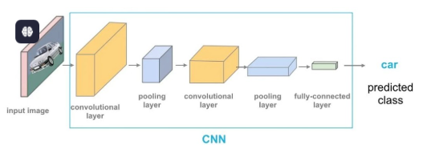

Figure 3.1: An example of using ViT

3.2. History of Transformer

The Transformer is a deep learning model that uses the self-attention mechanism to assign different weights to the importance of each part of the input data. Today, Transformers have become the model of choice for natural language processing (NLP) tasks, replacing RNN-based models such as long short-term memory (LSTM).

* + 2017: The Transformer model was introduced in the paper "Attention is All You Need" by Vaswani et al. This architecture revolutionized natural language processing by replacing recurrent models with attention mechanisms.
  + 2018: Google developed BERT (Bidirectional Encoder Representations from Transformers), which achieved state-of-the-art results in various NLP tasks.
  + 2018 - 2023: OpenAI's GPT models (Generative Pre-trained Transformers) demonstrated the power of large-scale transformers for text generation, culminating in advanced models like GPT-4.
  + 2020: Vision Transformers (ViT) applied the Transformer architecture to computer vision, challenging the dominance of convolutional neural networks (CNNs).

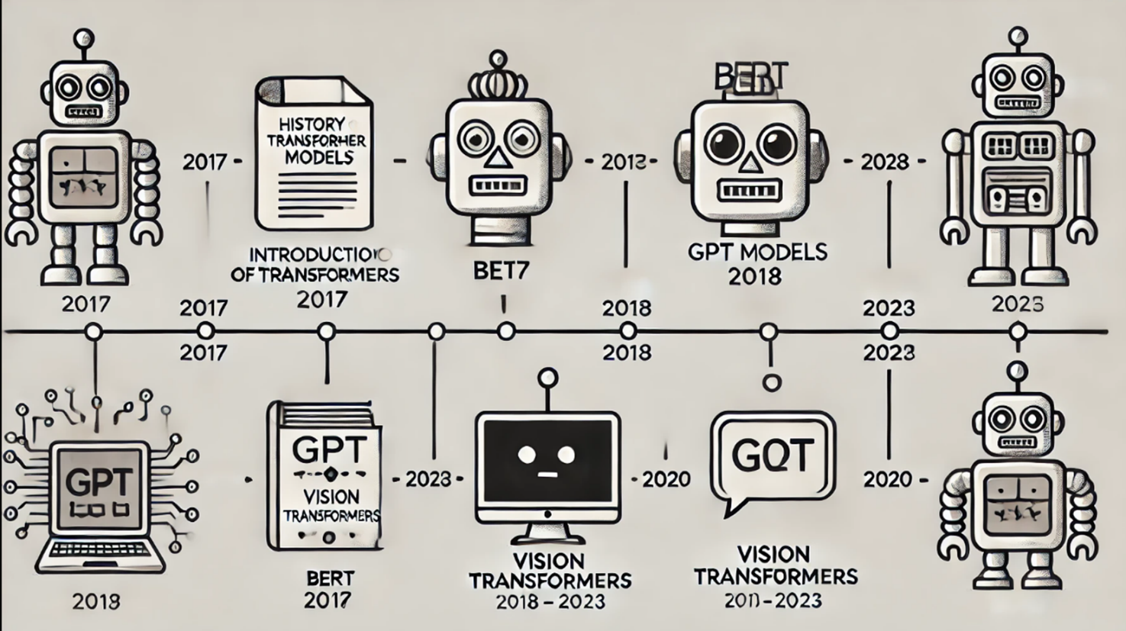

Figure 3.2: History of Transformer

3.3. Architecture of ViT

### *3.3.1. Dividing Images into Patches*

The input image is divided into fixed-size patches (e.g., 16×16 pixels). Each patch is then flattened into a vector and mapped into a higher-dimensional space.

An input image has dimensions $H×W×C$, where:

* $H$: Height of the image.
* $W$: Width of the image.
* $C$: Number of color channels (usually 3 for RGB).

ViT divides the image into non-overlapping patches, each of size $P×P$.  
The number of patches $N$ is calculated as:

$$N=\frac{H ×W}{P^{2}}$$

For example, with an image size of 224×224 and $P=16$, $N=196$ patches.

### *3.3.2. Creating Embeddings for Patches*

Each patch is flattened into a vector of length $P^{2}×C$.

These vectors are projected into an embedding space via a linear projection layer, resulting in feature vectors $z_{1},z_{2},…,z_{N}$ ​.

### *3.3.3. Transformer Encoder*

+ **Multi-Head Self-Attention (MHSA):** Combines the outputs of all attention heads linearly. Multiple attention heads help capture both local and global dependencies in the image.

+ **Multi-Layer Perceptron (MLP):** A two-layer Gaussian Error Linear Unit (GELU) function.

+ **Layer Normalization:** Added before each block to reduce overfitting and improve training efficiency.

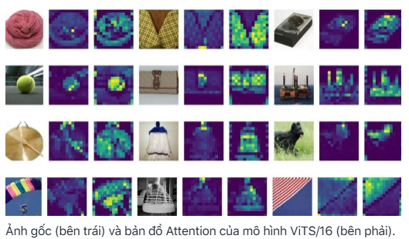

### *3.3.4. Classification Head*

+ ViT adds a special token (classification token [CLS]) to the input patches.

+ After passing through the transformer encoder layers, the [CLS] token contains the aggregate information of the entire image and is passed through a fully connected layer to predict the label.

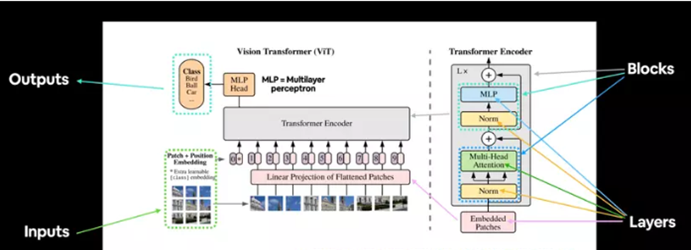

Figure 3.3: Architecture of ViT

Summary of ViT Architecture:

1. Patch + Position Embedding: Converts input images into a sequence of patches and adds positional information.
2. Embedded Patches: These are learnable embeddings of the patches.
3. Layer Normalization: Reduces overfitting by normalizing inputs.
4. Multi-Head Self-Attention (MSA): Captures both local and global dependencies.
5. Multi-Layer Perceptron (MLP): A feedforward network with non-linear activations.
6. Transformer Encoder: A stack of MSA and MLP blocks with residual connections.
7. MLP Head: The output layer that converts learned features into class predictions.

3.4. How Vision Transformers Work

### *3.4.1. Multi-Head Self-Attention (MHSA)*

MHSA is central to ViT, allowing the model to learn relationships between patches through attention computation. MHSA enables the model to focus on important regions in the image, both near and far, for a better understanding of the overall structure.

The attention mechanism is calculated as:

$$Attention\left(Q,K,V\right)=softmax\left(\frac{QK^{T}}{\sqrt{d_{k}}}\right)V$$

Where:

* $Q$ (Query): Represents feature vectors of the patches to "focus on."
* $K$ (Key): Represents feature vectors of the patches used to compute relevance.
* $V$ (Value): Contains the actual information to extract based on attention scores.
* $d_{k}$ ​: Dimension of the key vectors.

### *3.4.2. Multi-Head Attention*

Instead of computing a single attention, MHSA computes multiple attentions in parallel (called "heads"). Each head learns different relationships between patches, helping the model capture multi-dimensional information.



Steps of MHSA:

1. Split $Q,K,V$ into $h$ parts (with $h$ being the number of heads).
2. Compute attention for each head independently.
3. Concatenate the outputs from all heads.
4. Multiply with a weight matrix $W_{O}$ to aggregate information.

### *3.4.3. Positional Encoding*

Since Transformers lack spatial locality concepts, ViT adds positional information to the embedding vectors through Positional Encoding. The input vector is computed as:

$$Input Vector=Patch Embedding+Positional Encoding$$

3.5. Differences Between CNNs and Vision Transformers (ViT)

### *3.5.1. Architecture and Working Principles*

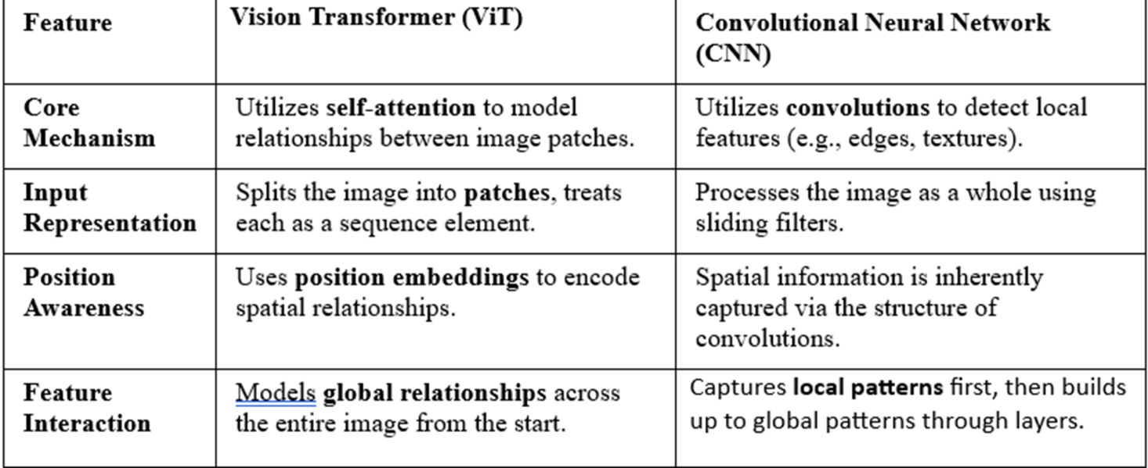

Figure 3.5.1: Compare CNNs and ViT about Architecture and Working Principles

### *3.5.2. Performance and Efficiency*

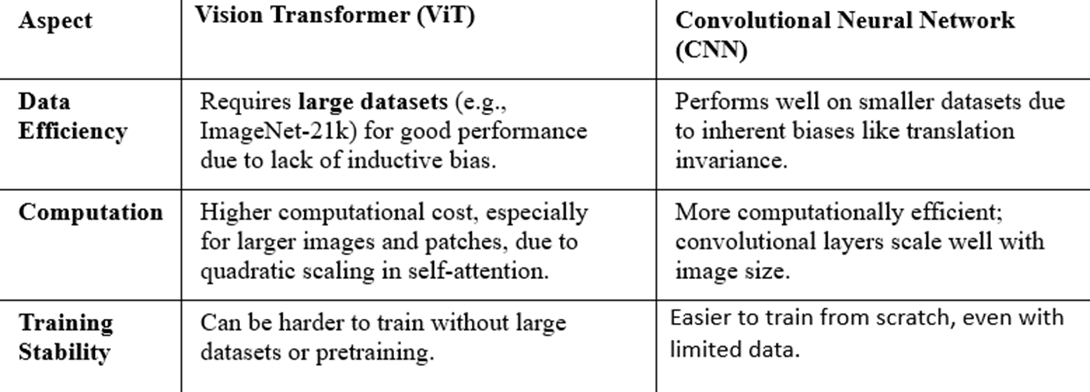

Figure 3.5.2: Compare CNNs and ViT about Performance and Efficiency

### *3.5.3. Strengths*

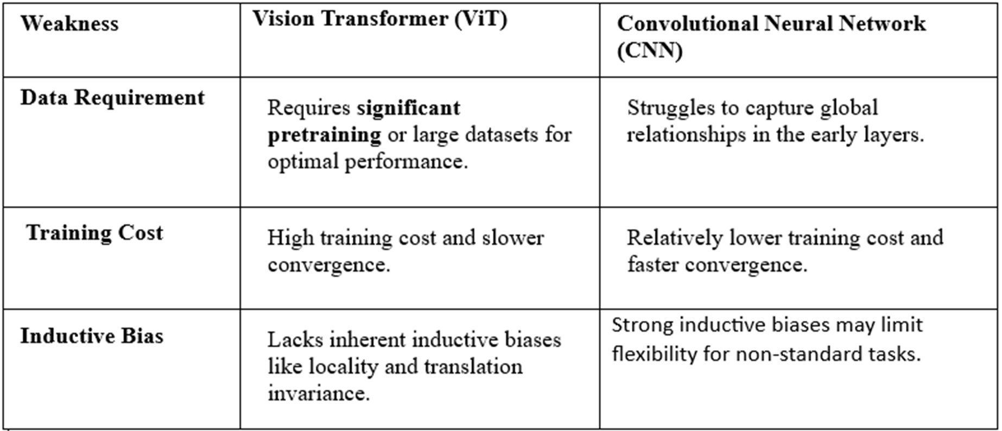

Figure 3.5.3: Compare CNNs and ViT about Strengths

### *3.5.4. Weaknesses*



Figure 3.5.4: Compare CNNs and ViT about Weaknesses

### *3.5.5. Applications*

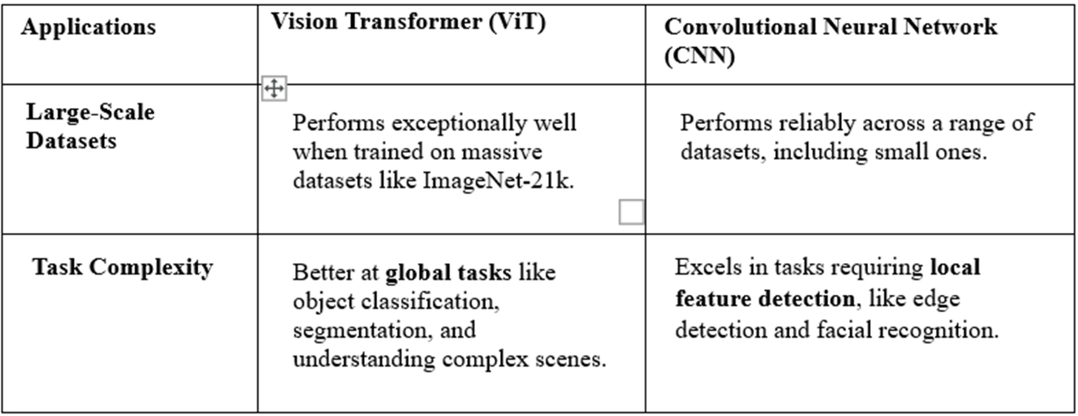

Figure 3.5.5: Compare CNNs and ViT about Applications

3.6. Advantages of Vision Transformers

### *3.6.1. Superior Performance on Large Datasets*

* When trained on large datasets (e.g., JFT-300M), ViT outperforms advanced CNN models like ResNet or EfficientNet.
* The self-attention mechanism allows better learning of long-term relationships in data.

### *3.6.2. Strong Generalization Capabilities*

* Unlike CNNs, ViT does not rely on assumptions about "locality." This enables ViT to generalize well to diverse datasets.
* ViT can learn complex relationships between parts of an image, even when they are not spatially adjacent.

### *3.6.3. Powerful Attention Mechanism*

* MHSA helps ViT focus on important regions in the image, regardless of their spatial distances.
* This is particularly useful in tasks requiring long-range dependency understanding.

3.7. Limitations of Vision Transformers

### *3.7.1. Requires Large Datasets*

* ViT needs massive training datasets to achieve good performance, whereas CNNs perform well even on smaller datasets.

### *3.7.2. Computational Complexity*

* MHSA has a complexity of $O(N^{2})$, requiring significant computational resources as the number of patches $N$ increases.

### *3.7.3. Inefficient for Local Information*

* ViT is less effective than CNNs at capturing local features such as edges and corners in small images.

3.8. Applications of Vision Transformers

### *3.8.1. Healthcare*

* **Medical Image Diagnosis:** ViT supports analysis of medical images like X-rays, MRI, and CT scans, helping detect abnormalities with high accuracy.
* **Surgery:** ViT can assist in analyzing and detecting diseases such as cancer and other pathologies.

### *3.8.2. Retail and E-commerce*

* **Product Recognition:** ViT helps identify products in images, aiding inventory management and checkout processes.
* **Personalized Recommendations:** By analyzing image content, ViT can suggest similar products that match customer preferences.

### *3.8.3. Security and Surveillance*

* **Face Recognition:** ViT improves the accuracy of facial recognition systems in security applications.
* **Anomaly Detection:** ViT can detect unusual activities or objects in surveillance footage, enhancing security.

# CHAPTER 4. INTRODUCTION TO R-CNN AND ITS VERSIONS

4.1. The introduction to R-CNN

R-CNN is one of the first convolutional neural network architectures widely used for object recognition and classification, introduced by Ross Girshick in 2014.

### *4.1.1. Basic concepts*

* + R-CNN is a method that combines region proposals and convolutional neural networks (CNN)
  + Objective: Identify and classify objects in images

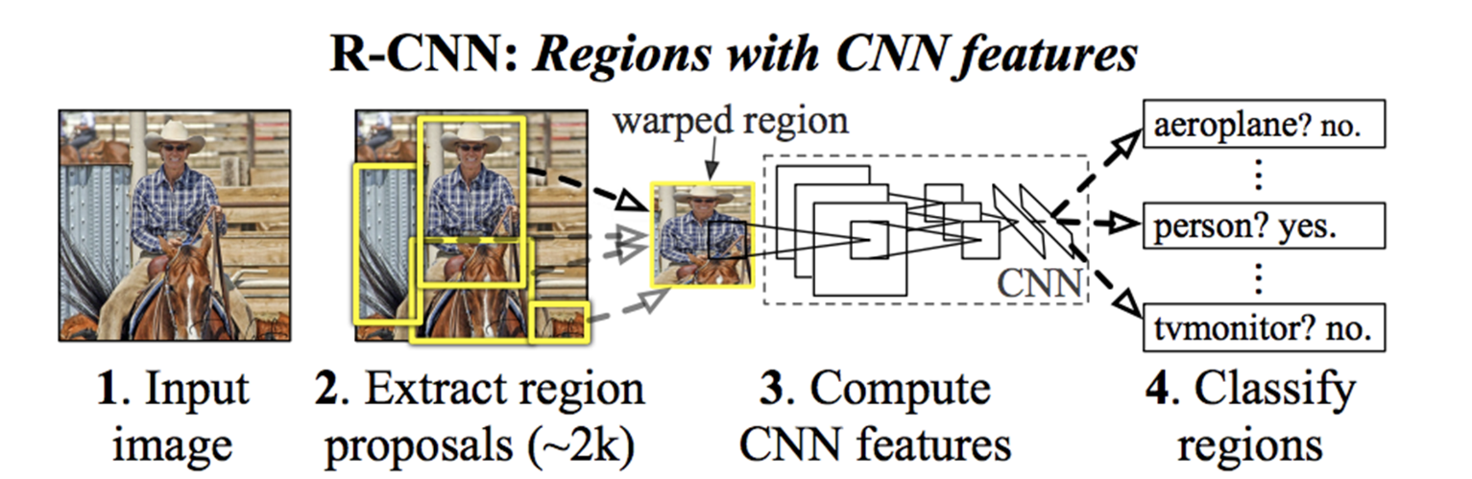

Figure 4.1: Basic concepts of R-CNN

### *4.1.2. The architecture will be divided into 3 steps*

+ Step 1: Region Proposals generation:

* Using a region selection algorithm such as Selective Search to generate about 2000 candidate regions that are likely to contain objects.
* These regions are created based on features such as:
  + Color similarity
  + Texture similarity
  + Pixel intensity differences
  + Region continuity
    - Step 1*: Region preprocessing stage:
      * Each proposed region is:
      * Croped from the original image.
      * Resized to a fixed size (usually 224x224 pixels).
      * Transform to appropriate color space.

+ Step 2: Feature extraction:

* Using CNN pre-trained networks such as AlexNet or VGG16 to extract features.
* Remove the last fully connected layer.
* Extract features of each image region into feature vectors.
* Each vector has about 4096 dimensions.

+ Step 3: Classification:

* Use SVM classifiers to recognize the type of object based on the feature vectors.
* At the same time, adjust the position of the bounding box to match and accurately match the recognized object.

### *4.1.3. Advantages*

* High accuracy.
* Capable of detecting multiple objects in a single image.

### *4.1.4. Disadvantages*

* Slow processing speed due to applying CNN to each region proposal.
* Requires significant computational resources and is complex to train because it needs a separate SVM model for classification and another model for bounding box prediction.

### *4.1.5. Improved versions*

* Fast R-CNN
* Faster R-CNN
* Mask R-CNN

4.2. The introduction to Fast R-CNN

In the previous section, we learned about the R-CNN model. Realizing that the R-CNN model (2014) had some shortcomings, Girshick introduced a more improved model called Fast R-CNN (2015) to address those limitations.

### *4.2.1. Description*

* Fast R-CNN improves performance by passing the entire input image through the CNN only once, producing a single feature map.
* Region proposals (ROIs) are mapped directly onto this feature map and processed using an ROI pooling layer to extract fixed-length feature vectors.
* Finally, a single network is used for both classification and bounding box regression.

### *4.2.2. Advantages*

* Faster than R-CNN as CNN is run only once.
* Does not require separate SVM models.

### *4.2.3. Disadvantages:*

* Region proposal (Selective Search) is still slow.

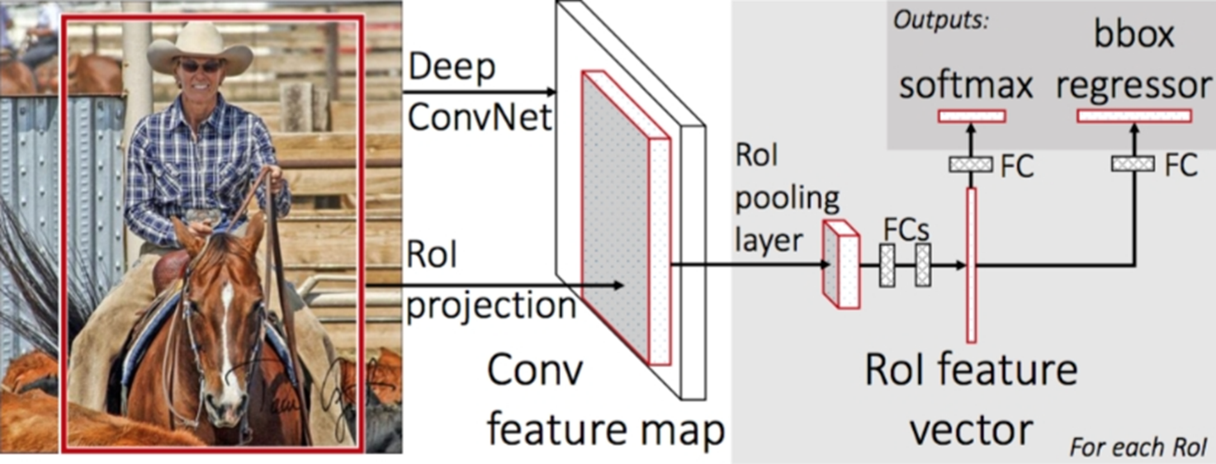

Figure 4.2.a: Architecture of Fast R-CNN

**Explanation for Figure 4.2:**

1. **Input Image (left):**
   * This is the original image, where the Region of Interest (RoI) is marked by a red box. This is the area that the system suspects contains the object to be recognized (e.g., a person riding a horse).
2. **Deep Convolutional Network:**
   * The input image is passed through a deep convolutional neural network (Deep ConvNet) to extract features. The output is a **Feature Map**.
3. **RoI Projection:**
   * The Region of Interest (RoI) in the input image is projected onto the Feature Map. This means that the corresponding positions of the RoI in the original image are identified on the Feature Map.
4. **RoI Pooling Layer:**
   * After identifying the location of the RoI on the Feature Map, the RoI Pooling layer normalizes the size of the RoI (even if the original RoI sizes are different). The result is a **fixed-size RoI feature vector**.
5. **Fully Connected Layers (FC):**
   * The RoI feature vector is passed through fully connected layers (FC). This process transforms spatial features into more abstract features.
6. **Outputs:**
   * The system produces two main outputs:
     + **Softmax:** Predicts the label of the object in the RoI (e.g., "person" or "horse").
     + **BBox Regressor:** Predicts bounding box adjustments to help localize the object more accurately.

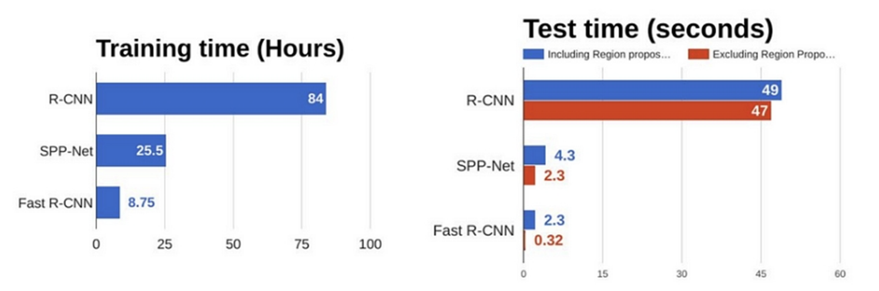

Figure 4.2.b: Compare the runtime between models

Fast R-CNN still uses Selective Search to generate region proposals. This is the bottleneck that limits the performance of Fast R-CNN, which can be seen in the second image below with the test time of Fast R-CNN when using Selective Search to generate region proposals. At this time, the time to process an image is up to more than 2 seconds. This is the disadvantage that makes Fast R-CNN unable to run in real time.

4.3. The introduction to Faster R-CNN

Instead of using selective search to determine region proposals of Fast R-CNN, Faster R-CNN uses Region proposal network (RPN) to predict region proposals. These predicted region proposals are reshaped using RoI pooling layer and used for classification and determining the offsets of bounding boxes.

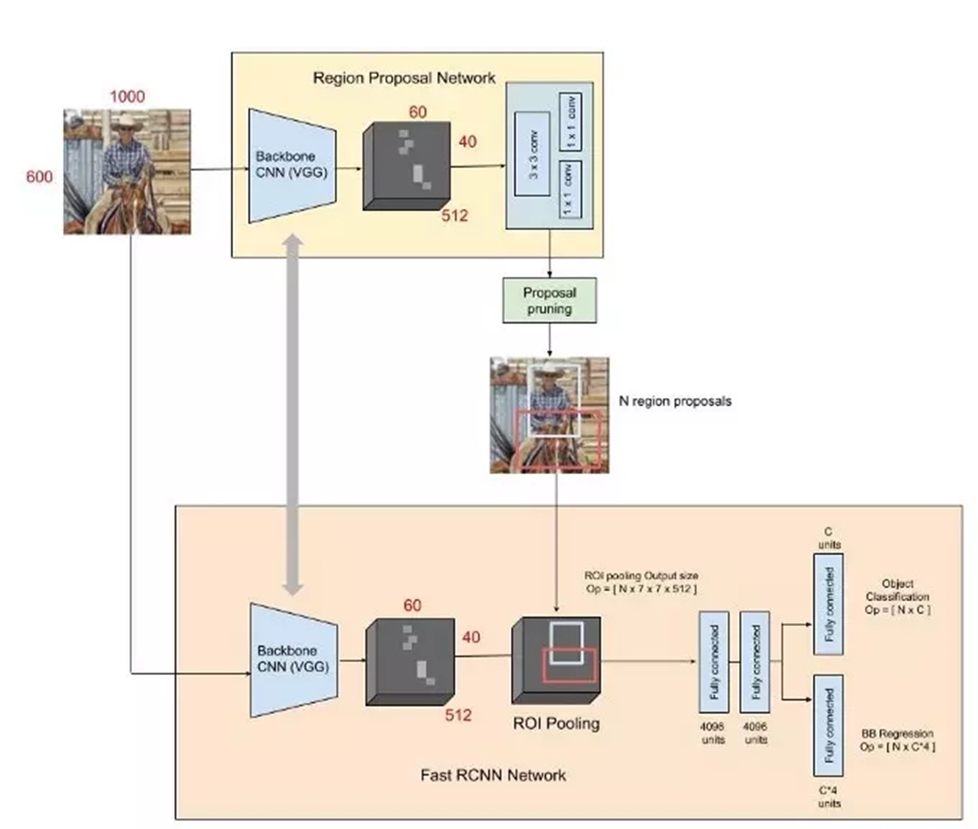

Figure 4.3: Architecture of Faster R-CNN

### *4.3.1. Key Components of Faster R-CNN*

a. Base Network (Backbone):

The base network extracts feature maps from the input image. Typical pre-trained models used as backbones include:

* + VGGNet (used in the original paper).
  + ResNet, DenseNet, EfficientNet, and others for modern applications.

b. Region Proposal Network (RPN):

RPN is a small fully convolutional network designed to propose potential object regions directly from the feature map.

* + Inputs: Feature map from the backbone network.
  + Outputs:
    - Objectness Scores: Probability of whether a region contains an object or not.
    - Bounding Box Coordinates: Adjusts the region's position and size.
  + Anchor Boxes:
    - RPN uses predefined anchor boxes (at different scales and aspect ratios) to predict proposals.
    - Each anchor box is scored for object presence and adjusted spatially.

c. RoI Pooling Layer (Region of Interest Pooling):

* + Converts regions of varying sizes into fixed-size feature maps.
  + These fixed-size features are then passed to the classification and regression layers.

d. Output Layers:

* + Softmax Classifier: Assigns a class label to each region.
  + Bounding Box Regressor: Refines the bounding box coordinates.

### *4.3.2. Architecture Workflow*

* 1. Feature Extraction:
     + Input image passes through the backbone network to produce a feature map.
  2. Region Proposal:
     + RPN predicts potential object regions (region proposals).
  3. Feature Pooling:
     + RoI Pooling extracts fixed-size feature maps for each proposal.
  4. Classification & Regression:
     + Feature maps are classified into object categories, and bounding boxes are refined.

### *4.3.3. Advantages of Faster R-CNN*

* Efficiency:
  + Integration of RPN eliminates the need for external region proposal methods.
  + Reduces computational overhead compared to Fast R-CNN.
* Accuracy:
  + Generates high-quality region proposals using shared feature maps.
  + Effective for detecting small or overlapping objects.

### *4.3.4. Limitations*

* Speed:
  + Although faster than Fast R-CNN, it is not real-time for applications like video processing.
* Complexity:
  + The architecture involves multiple stages, making it challenging to train.
* Memory Usage:
  + High memory requirements due to the use of anchor boxes and RPN.

### *4.3.5. Applications*

+ Faster R-CNN is widely used for object detection tasks in various fields:

* Autonomous Vehicles: Detecting pedestrians, vehicles, traffic signs.
* Medical Imaging: Identifying anomalies like tumors in X-rays or CT scans.
* Retail and Surveillance: Detecting people or objects in crowded spaces.
* Wildlife Monitoring: Identifying species in environmental monitoring systems.

### *4.3.6. Advances and Variants*

+ Since Faster R-CNN's release, it has inspired many subsequent models:

a. Mask R-CNN:

* Extends Faster R-CNN by adding a branch for instance segmentation, predicting masks for objects.
* Introduces RoI Align for better spatial accuracy.

b. Cascade R-CNN:

* Improves multi-stage object detection by refining region proposals iteratively.

c. Double-Head R-CNN:

* Introduces dual branches for classification and localization to handle diverse object features.

d. Hybrid Task Cascade (HTC):

* Enhances both object detection and segmentation in a unified framework.

### *4.3.7. Modern Improvements*

+ To make Faster R-CNN more competitive with one-stage detectors like YOLO or SSD, researchers have incorporated:

* Feature Pyramid Networks (FPN): Improves multi-scale detection by combining features from different layers.
* Deformable Convolutions: Enhances spatial adaptability for complex object shapes.
* Efficient Backbones: Using lightweight models like MobileNet to reduce computation.

### *4.3.8. Comparison with Other Object Detectors*

|  |  |  |  |  |
| --- | --- | --- | --- | --- |
| **Model** | **Stage** | **Speed** | **Accuracy** | **Use Case** |
| Faster R-CNN | Two-Stage | Medium | High | General-purpose detection. |
| YOLO (v4/v5) | One-Stage | Fast (Real-Time) | Moderate to High | Real-time tasks, video streams. |
| SSD | One-Stage | Fast | Moderate | Lightweight applications. |
| Mask R-CNN | Two-Stage | Medium | High + Segmentation | Instance segmentation tasks. |

Table 4.3.8: Comparison with Other Object Detectors

4.4. The introduction to Mask R-CNN

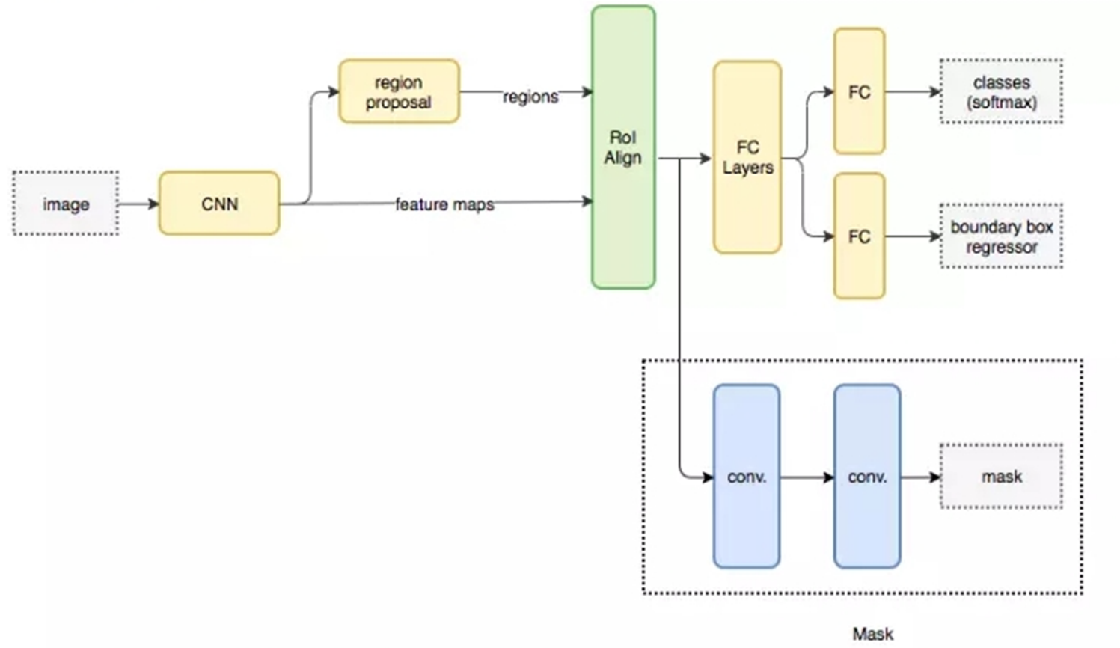

Figure 4.4: Architecture of Mask R-CNN

### *4.4.1. What is Mask R-CNN?*

+ Mask R-CNN is a deep learning model extended from Faster R-CNN, which aims to solve three tasks in image processing:

* Object Detection: Determine the location and label of objects in the image.
* Object Segmentation: Assign labels to each pixel for specific objects in the image.
* Object Classification: Assign category labels to each object.

### *4.4.2. Architecture of Mask R-CNN*

+ Mask R-CNN consists of the following main components:

a. Backbone (Feature Extraction Network)

* Uses a CNN (e.g., ResNet, ResNeXt) to extract features from the input image.
* May integrate a Feature Pyramid Network (FPN) to improve performance across objects of varying sizes.

b. Region Proposal Network (RPN)

* Generates region proposals by predicting potential object bounding boxes (Anchors).
* Anchors are predefined rectangular boxes of various aspect ratios and scales.

c. RoIAlign

* An improvement over RoIPool from Faster R-CNN.
* Eliminates quantization errors when mapping proposals to a fixed size, thus enhancing accuracy.

d. Output Heads

* Mask R-CNN introduces a segmentation branch (Mask Head) parallel to the classification and localization branches:
  + Classification Head: Predicts the object class label.
  + Bounding Box Regression Head: Predicts the bounding box coordinates of the object.
  + Mask Head: Predicts a binary segmentation mask for each object.

### *4.4.3. Key Improvements*

+ RoIAlign: Enhances accuracy in mapping proposals by using bilinear interpolation, removing quantization errors.

+ Multi-task Loss: Mask R-CNN employs a combined loss function for all three tasks:

* Classification Loss: Computes error in classifying object labels.
* Bounding Box Loss: Computes error in predicting bounding box coordinates.
* Mask Loss: Computes pixel-level error between predicted and ground-truth masks.

### *4.4.4. Advantages of Mask R-CNN*

* Versatility: Supports tasks like instance segmentation, object detection, and pose estimation.
* High Accuracy: Outperforms prior methods due to innovations in RoIAlign and loss functions.
* Easy to Extend: Can be applied to various tasks, such as human pose estimation.

### *4.4.5. Applications*

* Medical Image Segmentation: Identifying tumors or internal organs.
* Computer Vision: Processing satellite images, segmenting vehicles, or objects in images.
* Robotic Vision: Analyzing environments based on pixel information.
* Human Pose Estimation: Estimating the positions of body joints.

### *4.4.6. Datasets and Evaluation*

* COCO Dataset: Mask R-CNN is trained and evaluated on the COCO dataset, a standard for detection and segmentation tasks.
* Evaluation Metrics:
  + AP (Average Precision): Calculated for both bounding boxes and masks.

### *4.4.7. Limitations*

* High Computational Cost: Due to its complex architecture and pixel-level segmentation task.
* Large Data Requirement: Requires a substantial amount of annotated data for effective training.

# CHAPTER 5. INTRODUCTION TO AUTOENCODER

5.1. Overview of Autoencoder

+ **Autoencoder (AE)** is an unsupervised artificial neural network that learns to encode and reconstruct data.

+ It consists of two main parts:

* **Encoder**: Compresses the input data into a lower-dimensional feature space (latent space).
* **Decoder**: Reconstructs the data from the latent space back to its original form.

+ **Main Objectives**:

* Learn a more compact representation of the data (encoding).
* Reconstruct the input data from the learned representation with minimal error.

5.2. Autoencoder Architecture

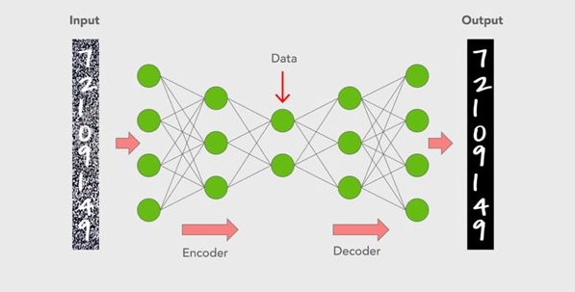

Figure 5.2: Architecture of AutoEncoder

+ Autoencoder has a neural network structure with three main parts:

**a. Encoder**

* Compresses input data $x$ into a feature vector $z$ in the lower-dimensional latent space.
* Mathematical representation:
 $$z=f\left(x\right)=σ(Wx+b)$$

 $x$ + : Input data.
  + $z$: Encoded (compressed) data in latent space.
  + $W$: Weight matrix.
  + $b$: Bias term.
  + $σ$: Activation function (ReLU, Sigmoid, Tanh, etc.).

**b. Bottleneck (Latent Space)**

* The middle layer with the smallest size, representing the most compressed version of the data.
* At this layer, the Autoencoder learns to retain the most essential information of the data.

**c. Decoder**

* Decodes the latent vector $z$ to reconstruct the data $\hat{x}$.
* Mathematical representation:
 $$\hat{x}=g\left(z\right)=σ'(W'z+b')$$

 $\hat{x}$ + : Reconstructed data.
  + $W^{'},b'$: Decoder weights and bias.

5.3. Loss Function

* Autoencoder optimizes to minimize the difference between the input data $x$ and the reconstructed data $\hat{x}$.
* **Common loss functions:**
  + Mean Squared Error (MSE):
 $$L\left(x,\hat{x}\right)=\frac{1}{n}{\sum_{i=1}^{n}{{(x}_{i}-{\hat{x}}_{i})}}^{2}$$

 + Cross-Entropy Loss (used for binary data):

$$L\left(x,\hat{x}\right)=-\sum_{i=1}^{n}{{[x}_{i}\log{({\hat{x}}_{i})}+(1-x_{i})\log{(1-{\hat{x}}_{i})}]}$$

5.4. Types of Autoencoders

+ Autoencoder has several variants suited for specific applications:

**a. Vanilla Autoencoder**

* The basic Autoencoder consisting of an Encoder and a Decoder.
* Used for simple data reconstruction or dimensionality reduction.

**b. Denoising Autoencoder (DAE)**

* Trained with noisy data to reconstruct the original clean data.
* **Objective:** Remove noise and reconstruct clean data.
* Example: Reconstructing an image from blurred or noisy input.

**c. Sparse Autoencoder**

* Adds constraints to ensure $z$ has many elements close to 0 (sparse representation).
* **Objective:** Learn rare or unique features.

**d. Variational Autoencoder (VAE)**

* Converts the latent space into a probability distribution instead of a fixed vector.
* **Objective:** Generate new data by sampling from the latent space.
* Applications: Generating images, text, or synthetic data.

**e. Convolutional Autoencoder (CAE)**

* Uses convolutional layers (CNN) in the Encoder and Decoder to handle image data.
* **Objective:** Extract spatial features.

**f. Contractive Autoencoder**

* Adds constraints to the latent space to enhance the stability of encoding when the input data changes slightly.

5.5. Applications of Autoencoder

+ Autoencoders are widely used in various fields:

**a. Dimensionality Reduction**

* Reduces data dimensions, similar to PCA, but can capture nonlinear relationships.

**b. Anomaly Detection**

* Autoencoders learn normal patterns and detect anomalies by identifying data with high reconstruction error.

**c. Image Processing**

* Image denoising.
* Reconstructing missing pixels in images (inpainting).

**d. Data Generation**

* Variational Autoencoders (VAE) can generate new data, such as images or text, by sampling from the latent space.

**e. Indirect Classification**

* Uses the feature space of the Autoencoder as input to classification models.

5.6. Advantages and Limitations of Autoencoder

**Advantages:**

* Can learn complex nonlinear features better than PCA.
* Easily scalable to handle various data types: images, text, signals.
* Works for both supervised and unsupervised tasks.

**Limitations:**

* Output data depends heavily on the model's quality and structure.
* Requires sufficient training data to ensure good reconstruction.
* May not always outperform linear methods (like PCA) for simple datasets.

# CHAPTER 6. INTRODUCTION TO GAN

6.1. Overview of GAN

* **Generative Adversarial Networks (GAN)** are a type of neural network designed to generate new data by employing an adversarial approach between two networks:
  + **Generator (G):** Learns to create new data resembling real data.
  + **Discriminator (D):** Distinguishes between real data and fake data generated by the Generator.
* The GAN framework was first introduced by **Ian Goodfellow** and colleagues in 2014 in the paper *“Generative Adversarial Nets.”*

6.2. Basic Structure of GAN

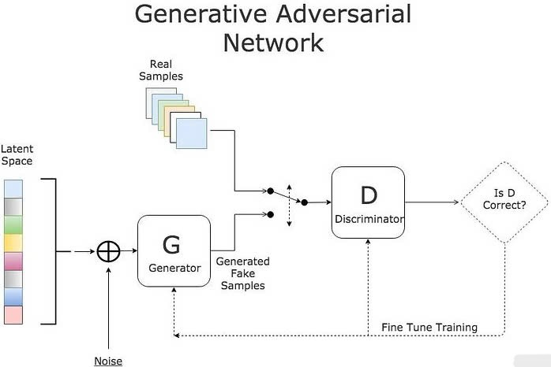

Figure 6.2: Architecture of GAN

GAN consists of two main components:

**a. Generator (G)**

+ The Generator takes a random vector $z$ (often sampled from a Gaussian or Uniform distribution) as input and generates fake data $G(z)$ to mimic real data.

+ **Objective of the Generator:**

* Optimize to fool the Discriminator, making $D\left(G\left(z\right)\right)≈1$ (Discriminator believes fake data is real).

+ **Loss function of the Generator:**

$$L_{G}=-\log\left(D\left(G\left(z\right)\right)\right)$$

**b. Discriminator (D)**

+ The Discriminator acts as a classifier to distinguish between real data xxx and fake data .

+ **Objective of the Discriminator:**

* Maximize the ability to distinguish between real and fake data, ensuring $D\left(x\right)→1$ (real) and $D\left(G\left(z\right)\right)→0$ (fake).

+ **Loss function of the Discriminator:**

$$L_{D}=-\left[\log\left(D\left(x\right)\right)+\log\left(1-D\left(G\left(z\right)\right)\right)\right]$$

6.3. Working Principle of GAN

+ **Key Idea:** GAN operates like a game between the Generator and the Discriminator, described as a *min-max game.*

+ **Overall Objective Function:**

+ **Training Process:**

* The Discriminator is trained to differentiate between real and fake data.
* The Generator is trained to fool the Discriminator, improving the quality of the generated data.

6.4. Training Procedure

1. **Step 1:** Train the Discriminator:
   * Use both real data $x \sim p_{data}(x)$ and fake data $G\left(z\right)$.
   * Optimize the loss function $L_{D}$ ​.
2. **Step 2:** Train the Generator:
   * Use random vectors $z \sim p_{z}(z)$ to generate fake data $G\left(z\right)$.
   * Optimize the loss function $L_{G}$ to fool the Discriminator.
3. **Repeat:** Iterate this process until the Generator produces data indistinguishable from real data.

6.5. Common Challenges in GAN

**a. Mode Collapse**

* The Generator only produces one or a few repeated types of data.
* **Cause:** The Generator optimizes toward outputs that the Discriminator consistently evaluates as high quality.

**b. Unstable Training**

* Training GANs may not converge due to the adversarial nature of the two networks.
* **Result:** Poor data quality or failure to generate meaningful outputs.

**c. Vanishing Gradient**

* When the Discriminator is too strong, the Generator fails to receive meaningful gradient updates to learn effectively.

6.6. Variants of GAN

**a. Conditional GAN (cGAN)**

* Adds conditional information $y$ to both the Generator and Discriminator.
* **Application:** Generate data for specific labels (e.g., creating images of dogs or cats).

**b. Wasserstein GAN (WGAN)**

* Replaces the loss function with the Wasserstein distance for more stable training.
* **Application:** Solves vanishing gradient issues.

**c. CycleGAN**

* Transforms data between two domains (e.g., converting images from day to night).

**d. StyleGAN**

* Generates high-resolution images and allows control over specific attributes of the generated images.

6.7. Applications of GAN

* **Data Generation:** Creating fake images, videos, or text.
* **Super-Resolution:** Enhancing image resolution.
* **Deepfake:** Generating fake faces or videos.
* **Style Transfer:** Producing images in different artistic styles.
* **Medical Applications:** Generating medical imaging data to support research.

# REFERENCES

Y. LeCun, L. Bottou, Y. Bengio, and P. Haffner, “Gradient-based learning applied to document recognition,” *Proceedings of the IEEE*, vol. 86, no. 11, pp. 2278–2324, Nov. 1998.

G. Hinton, S. Osindero, and Y. Teh, “A fast learning algorithm for deep belief nets,” *Neural Computation*, vol. 18, no. 7, pp. 1527–1554, Jul. 2006.

A. Krizhevsky, I. Sutskever, and G. Hinton, “ImageNet classification with deep convolutional neural networks,” in *Advances in Neural Information Processing Systems (NIPS)*, 2012, pp. 1097–1105.

K. Simonyan and A. Zisserman, “Very deep convolutional networks for large-scale image recognition,” arXiv:1409.1556, 2014.

C. Szegedy et al., “Going deeper with convolutions,” in *Proc. IEEE Conf. Comput. Vis. Pattern Recognit. (CVPR)*, 2015, pp. 1–9.

K. He, X. Zhang, S. Ren, and J. Sun, “Deep residual learning for image recognition,” in *Proc. IEEE Conf. Comput. Vis. Pattern Recognit. (CVPR)*, 2016, pp. 770–778.

A. Dosovitskiy et al., “An image is worth 16x16 words: Transformers for image recognition at scale,” arXiv:2010.11929, 2020.

R. Girshick, “Fast R-CNN,” in *Proc. IEEE Int. Conf. Comput. Vis. (ICCV)*, 2015, pp. 1440–1448.

S. Ren, K. He, R. Girshick, and J. Sun, “Faster R-CNN: Towards real-time object detection with region proposal networks,” in *Advances in Neural Information Processing Systems (NIPS)*, 2015, pp. 91–99.

K. He et al., “Mask R-CNN,” in *Proc. IEEE Int. Conf. Comput. Vis. (ICCV)*, 2017, pp. 2980–2988.

I. Goodfellow et al., “Generative adversarial nets,” in *Advances in Neural Information Processing Systems (NIPS)*, 2014, pp. 2672–2680.

D. Kingma and M. Welling, “Auto-encoding variational Bayes,” arXiv:1312.6114, 2013.

V. Nair and G. Hinton, “Rectified linear units improve restricted Boltzmann machines,” in *Proc. 27th Int. Conf. Mach. Learn. (ICML)*, 2010, pp. 807–814.

X. Glorot, A. Bordes, and Y. Bengio, “Deep sparse rectifier neural networks,” in *Proc. 14th Int. Conf. Artif. Intell. Stat. (AISTATS)*, 2011, pp. 315–323.

M. Abadi et al., “TensorFlow: Large-scale machine learning on heterogeneous distributed systems,” arXiv:1603.04467, 2016.

J. Redmon et al., “You only look once: Unified, real-time object detection,” in *Proc. IEEE Conf. Comput. Vis. Pattern Recognit. (CVPR)*, 2016, pp. 779–788.

O. Russakovsky et al., “ImageNet large scale visual recognition challenge,” *Int. J. Comput. Vis.*, vol. 115, no. 3, pp. 211–252, Dec. 2015.

Z. Liu et al., “Swin transformer: Hierarchical vision transformer using shifted windows,” in *Proc. IEEE Int. Conf. Comput. Vis. (ICCV)*, 2021, pp. 10012–10022.

A. Vaswani et al., “Attention is all you need,” in *Advances in Neural Information Processing Systems (NIPS)*, 2017, pp. 5998–6008.

T.-Y. Lin et al., “Feature pyramid networks for object detection,” in *Proc. IEEE Conf. Comput. Vis. Pattern Recognit. (CVPR)*, 2017, pp. 2117–2125.